Prince William County Public Schools
Title I Office

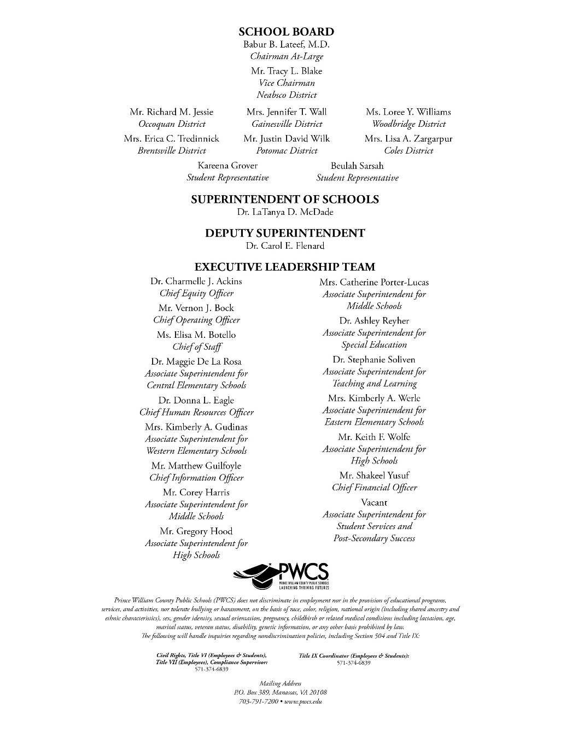
Enterprise Elementary
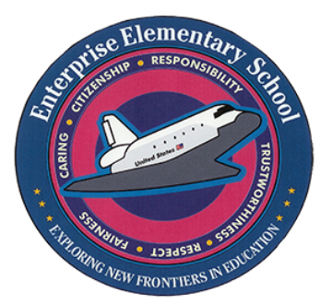
Title I Family -School Compact

School address: 13900 Lindendale Road
Woodbridge, Va 22193

Vision: Enterprise Elementary is a caring and collaborative learning community of critical thinkers and mindful leaders.

Mission: Enterprise Elementary is a caring and collaborative learning community of critical thinkers and mindful leaders by: operating under the a 4-House System: Four Houses—One Family; modeling the character traits of hope, kindness, strength, and perseverance; providing daily opportunities for academic conversation and productive struggle; providing leadership opportunities; creating daily engaging lessons where we problem-solve together; and providing a safe learning environment where we take risks and own our learning.
School year: 2026-2027

What is Title I?
Title I is a federal funded grant designed to help schools meet the needs of all students and to provide resources to help improve educational success for families.
School Connection Contacts
Luis Ramirez
Parent Liaison
ramirel@pwcs.edu

Kathryn Forgas
Principal
forgaske@pwcs.edu

Teresa Thornton
Assistant Principal
thornt@pwcs.edu

Abbie Saunders-Jeter
Title I Mathematics Teacher
saundea@pwcs.edu

Shannon Sherman
Title I Literacy Teacher
shermase@pwcs.edu

Family Engagement and Involvement Opportunities
- September 17, 2026: Pre-K – 2nd Grade Reading & Writing Parent Workshop
- October 1, 2026: Title I Annual Meeting & Back to School Night (schoolwide event)
- October 15, 2026: 3rd-5th Grade Math Word Problems Parent Workshop
- October 22, 2026: Math, Science, Book Fair Trunk or Treat (schoolwide event)
- November 16, 2026: 3rd-5th Grade Reading & Writing Parent Workshop
- December 10, 2026: Pre-K – 2nd Grade Number Sense & Computation Parent Workshop
- January 14, 2027: Winter Wonderland (schoolwide event)
- June 2, 2027: Summer Thrive

Agreements
Student Agreement
I will …
- Attend school daily
- Respect teachers and peers
- Work hard daily
- Set goals

Family/Parent Agreement
We will …
- Talk daily with student about day at school
- Make sure they come to school daily
- Check ParentVue and email regularly
- Attend school events
- Communicate with school and teachers
Teachers/Staff Agreement
We will …
- Provide a safe and caring learning environment for all
- Build relationships with students and families
- Communicate regularly with student and families about progress

